ApplePicker Micro GDD

Contents

Preparation 1

Game objects needed 2

Making rough assets quickly 2

Apple tree 2

Apple 2

Basket 3

Ground 3

Materials 3

Create and apply tags to objects 4

# Preparation

* Create a unity project 3D called ApplePicker
* Download a background image of an orchard from google; save it in a folder named backgrounds under Assets folder in Unity

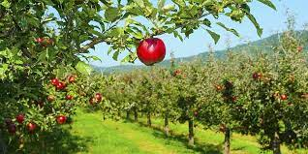

* Save SampleScene as Scene0

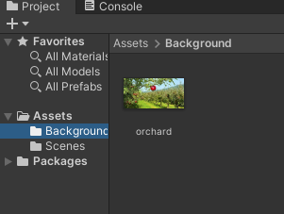

# Game objects needed

* Apple tree [-> prefab]
* Apple -> prefab
* Basket -> prefab

# Making rough assets quickly

## Apple tree

* 1 empty game object named AppleTree
* 1 child cylinder for the trunk
* 1 child sphere for leaves
* Leaf material
* Trunk material
* Created prefab

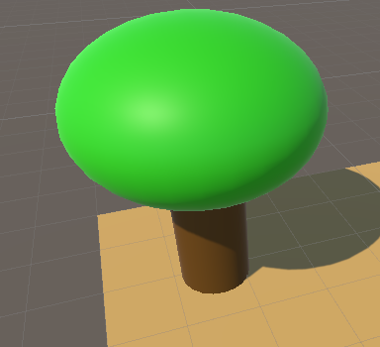

## Apple

* 1 sphere named Apple
* Apple material
* Created prefab

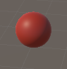

## Basket

* 1 cube named basket
* Basket material
* Created prefab

## Ground

* 1 plane named Ground
* Ground material
* Created prefab

## Materials

* Apple material
* Leaves material
* Ground material
* Basket material
* Trunk material

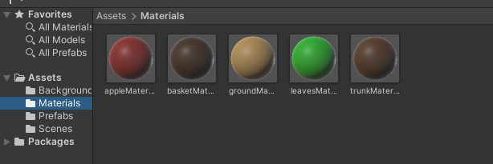

## Create and apply tags to objects

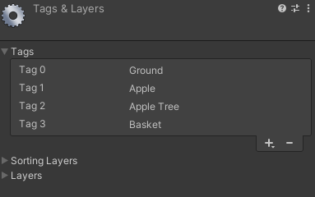

# Set up the camera

* Set projection to orthographic; set size to 16
* Size = half of height
* Height = 32 m
* Aspect ratio is width/height

# Scripting behavior of the game objects

Create scripts for each object

AppleTree

* Every frame moves on the current direction
* 10 % chance, or on hitting the side of the scene, change direction
* Timed to drop an apple